Practice Activity: Create a Newsletter in Microsoft Word
Before You Begin
✅ Download all attached files.
✅ Save the files in your Office Fund folder before starting.

Purpose
In this activity, you will create a newsletter for the Graphic Design Students at NBCC.
You will practice:

formatting text as columns,
editing pictures,
inserting screen clips,
symbols and special characters.

- Start Word and open Starter_Word_Practice3.
  - Save the file as FirstnameL_Word3 (example AynslieC_Word3) in your Word folder.
- Using Document Info, insert the file name in the footer.
- Select the first paragraph that begins with New Brunswick Community College
  - Apply Bold text
  - change the font color to Dark Green, Accent 3
    - (If you cannot find this exact colour, choose a green under the Theme Colors. then for each time in this practice this color appears again, choose the same green you chose).
- With the title still selected, go to the Home Tab > Paragraph Group > select the arrow next to Borders > choose Borders and Shading to launch the Dialogue Box.
    - Add a Dark Green, Accent 3, Darker 25%,
    - 2¼ pt solid line
    - bottom border.
- Select all the text beginning with Graphic Design Newsletter down to the end of the document excluding the final paragraph (starts with When you are finished).
  - On the Layout Tab > Page Setup Group > Set the columns to two.
  - Compare your screen to the image below:
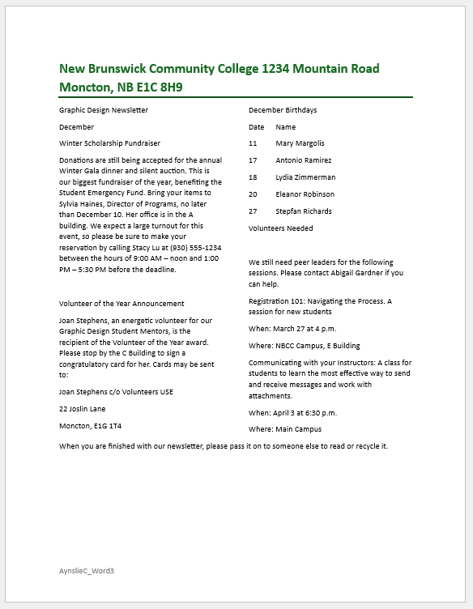
- With the two columns of text still selected, expand the paragraph setting of the Paragraph Group,
  - Under General change the alignment to justified.
  - Under Spacing change After to 6 pt
- Position the insertion before December Birthdays
  - On the Layout tab > Page Setup group > Select the ▼ beside Breaks > Set the Page Breaks to Column.
    - This will ensure the column of December Birthdays is a new column.
- Position the insertion point at the end of the document in the empty space after the paragraph that begins with When you are finished…
- On the Insert Tab > Illustrations Group > Select the ▼ beside Pictures.
  - Click This Device
  - Browse to where your downloaded files from Brightspace are stored
  - Insert the NBCC logo named Word_Practice3_Picture.
- With the picture selected, on the Picture Format Tab > Arrange Group > Select the ▼ near Wrap Text > select More Layout Options:
  - In the Position tab
    - Set horizontal alignment to Centered, relative to Column.
    - Set vertical alignment to Bottom, relative to Margin.
  - In the Text Wrapping Tab
    - Set text wrapping layout to Top and Bottom.
  - In the Size tab
    - Set picture height to 1.8".
  - Select OK.
- With the picture selected, on the Picture Format Tab > Size Group > choose Crop.
  - Using the Cropping handles on the picture, crop the picture until only the NBCC logo icon is visible.

    - The cropped image should look something like this:

- With the picture selected, on the Picture Format Tab > Arrange Group > Select the ▼ near Wrap Text > select More Layout Options:
  - In the Position tab
    - Set horizontal alignment to Centered, relative to Page.
    - Under Options, choose Lock Anchor
  - In the Text Wrapping Tab
    - Set text wrapping layout to Square.
  - In the Size tab
    - Under Scale, ensure Lock Aspect Ratio is checked
    - Set picture height to 1.5".
  - Click OK
- With the image still selected, zoom to 200%.
- On the Picture Format Tab, Adjust Group,
  - Choose the ▼next to Corrections.
    - Under Sharpen/Soften, choose Sharpen 50%.
    - Under Brightness/Contrast, choose Brightness: +20% Contrast +20%.
  - Choose the ▼next to Color
    - Under Color Saturation choose Saturation 400%
- With the picture still selected, set the Zoom back to 100%.
- Near the top of the document in the left column, delete the word December.
- Position the insertion point in the blank paragraph under Graphic Design Newsletter.
- Open a new web browser window and navigate to https://nbcc.ca/programs-courses/program-details?baseCurriculumId=b7c0d718-f880-4c39-b61c-5a9ccdc17f05
- Redisplay the newsletter and ensure the insertion point is in the paragraph below Graphic Design Newsletter.
- On the Insert Tab > Illustration Group > Choose the ▼next to Take a Screenshot, and then click Screen Clipping.
  - Start at the top of Graphic Design and drag to the lower right corner of the first box.
  - Ensure you leave white space around the clipping to accommodate a border
  - Your screen clip may vary based on the resolution and web browser utilized.
  - Compare your screen to the image below
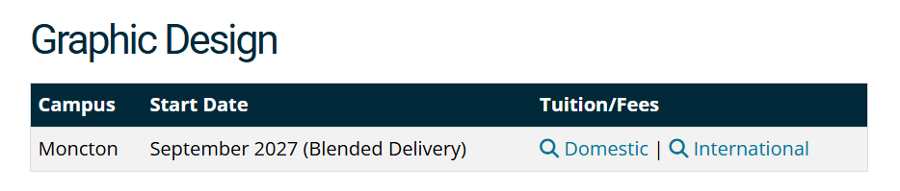
- With the picture still selected on the Picture Format Tab, choose Picture Styles, click the ▼next to Quick Styles and select the first Style: Simple Frame White.
Note: After inserting the screen clip, you may need to readjust the position and the size of the logo at the bottom of the document. Since the Text Wrapping is set to Square, you can manually adjust it by selecting and dragging it. The newsletter should only be one page.
- Near the top of the document, select the text Winter Scholarship Fundraiser
  - Change the font color to Dark Green, Accent 3.
  - Apply Bold
- With the text still selected, launch the Font dialogue box (Home Tab).
  - Under effects, choose the checkbox next to small caps.
- Using Format Painter, apply the same formatting to each of the heading paragraphs.
  - To use the Format Painter, select the text you want to copy.
  - Then select (double click) the Format Painter icon on the Home Tab, Clipboard Group.
  - Then, select the text that you would like to apply formatting to.
    - Volunteer of the Year Announcement
    - December Birthdays
    - Volunteers Needed
    - Communicating With Your Instructors
  - Click the Format Painter again to unselect
  - Remove the Space between Volunteers Needed and the line starting with We will need peer…
  - Add a space between the Birthday List and the heading Volunteers Needed
  - Add a space between the Volunteers Needed paragraph and the Communicating with your instructor patagraph
- Select the title of the document that begins with New Brunswick and ends with E1C 8H9 (including the paragraph mark).
  - Design Tab> Page Background Group > Page Borders > Borders tab
    - Apply a Dark Green, Accent 3, 1½ pt shadow border
  - Switch to the Shading tab
    - Apply a Dark Green, Accent 3 Lighter 60% shading fill
  - Center the text
- On the Design Tab, Choose Page Borders.
  - In the Page Borders Dialog Box, choose
  - the Box Border,
  - the style with a thick upper line and thin bottom line,
  - Automatic color,
  - 3pt width,
  - to the whole document.
- Save the document and compare it to the image below. Make any adjustments before submitting to the appropriate assignment box on Brightspace.
